**NOAA Dataset Visualization**

First step: We need to inspect our dataset to find out which columns we will use in our data visualization.

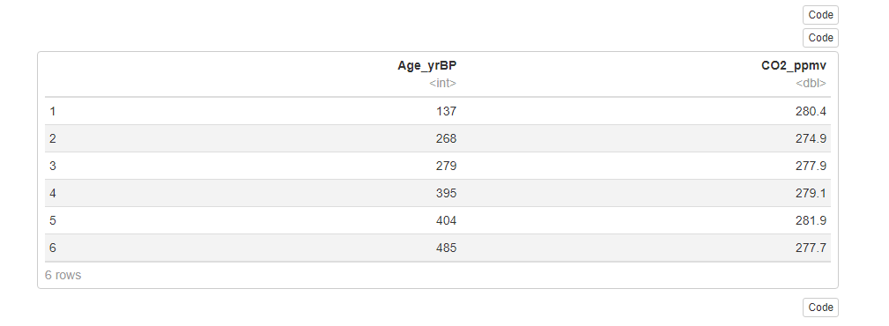

As you can see, our dataset consists of 2 columns: The year and the CO2 ppm. Those will be our x and y axis in our graph.

The purpose of this visualization is to demonstrate the fluctuations in the levels of Carbon Dioxide. Thus, it is best to use line graph.

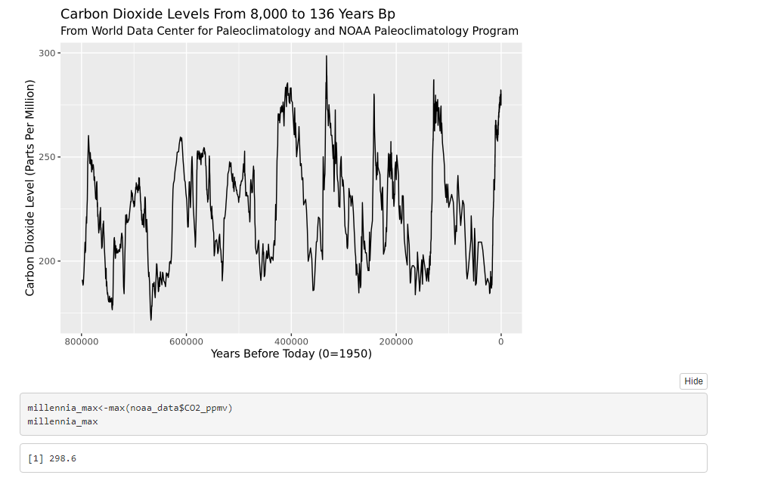

**IAC Dataset Visualization**

First step: We need to inspect our dataset to find out which columns we will use in our data visualization.

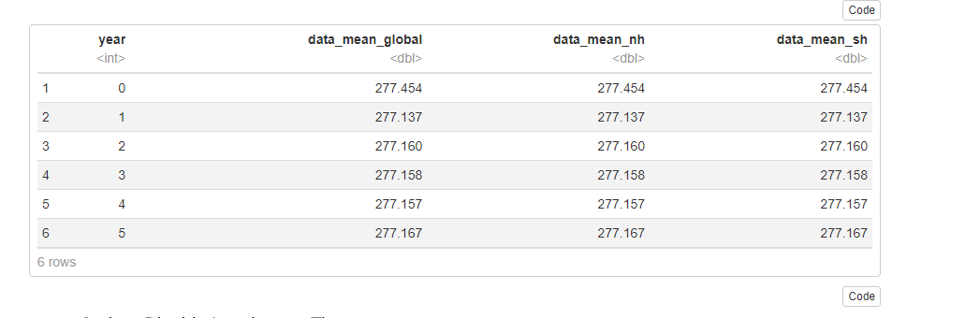

As you can see, our dataset consists of 4 columns, however, we only use the first 2 columns: The year and the CO2 ppm. Those will be our x and y axis in our graph.

The purpose of this visualization is to demonstrate the fluctuations in the levels of Carbon Dioxide. Thus, it is best to use line graph. Also, we need to make a comparison between the CO2 levels in the past (BP) and now. That’s why we need to find the maximum CO2 ppm in the first dataset and assign it as the y intercept in our second graph.

⇨From the result, we can see that before the 21st century, our CO2 ppm has passed the y intercept and still increases a lot.

